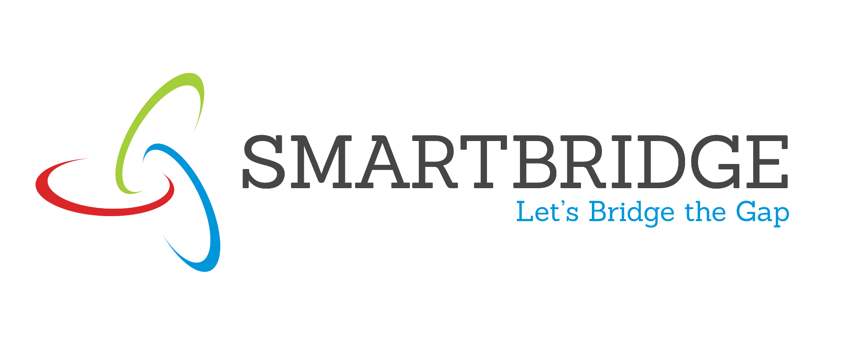 | 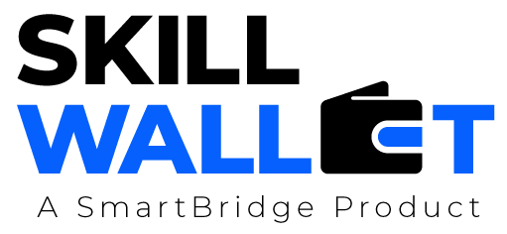
Project Initialization and Planning Phase
Date | 06 July 2026
Team ID | Individual Project
Project Name | VBCUA – Voice-Based Concept Understanding Analyser
Maximum Marks | 3 Marks
Define Problem Statements (Customer Problem Statement Template):
Create a problem statement to understand your customer's point of view. The Customer Problem Statement template helps you focus on what matters to create experiences people will love. A well-articulated customer problem statement allows you and your team to find the ideal solution for your customers' challenges. Throughout the process, you’ll also be able to empathize with your customers, which helps you better understand how they perceive your product or service.
Problem Statements — VBCUA Project:
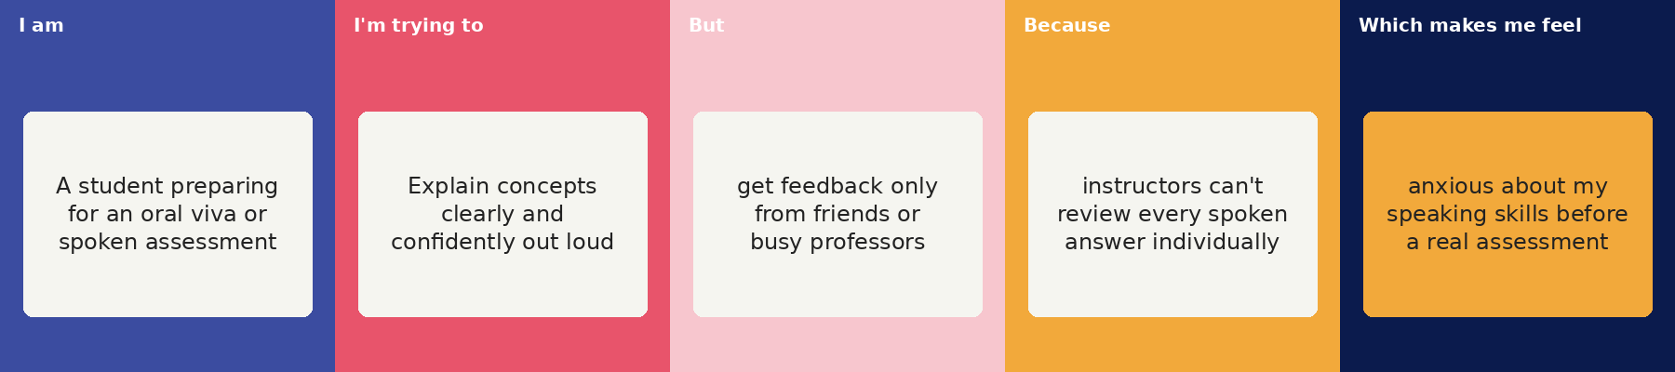
Problem Statement (PS) | I am (Customer) | I'm trying to | But | Because | Which makes me feel
PS-1 | A student preparing for an oral viva or spoken assessment. | Explain concepts clearly and confidently out loud. | get feedback only from friends or busy professors. | instructors don't have time to review every spoken answer individually. | anxious about my speaking skills before a real assessment.
PS-2 | A teacher evaluating many students' spoken understanding. | objectively assess each student's conceptual clarity and delivery. | can't listen to and grade dozens of recordings individually. | manual evaluation of speech is slow and inconsistent across a large class. | overwhelmed by the time manual spoken assessment takes.
PS-3 | A job seeker preparing for technical or behavioral interviews. | reduce filler words, pauses, and sound more confident when speaking. | have no objective way to measure how I actually sound. | self-recording is hard to evaluate accurately without expert feedback. | uncertain and underprepared heading into real interviews.

